Still in production
Description | Barcode String | Barcode | Len | Ver
CAC PDF417 VN | NQ3E586T1RKL3VUManfred Houston ATKNAA00CPT MO03B8MHB9OO2K |  | 89 | N
USID PDF417 Sponsor V3 | IDUS3♥*ÇÆ1GORRELL, LIDIA 9991001041 0060150RDBR1992OCT31NNYYUNONE NONE 2RRT 2011NOV042052OCT308 5RESRETUSAF AMN E1 I UNK | 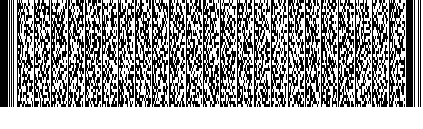 | 155 | 3
USID PDF417 Dependant V3 | IDUS3♥∩ⁿ╢0TESLIN, WOMAN 99988999819998899980155100GYGY1991NOV17SMYYU2010NOV172013NOV151173 2010NOV172013NOV15S BAD USN NON-POE2 TESLIN, TESLIN 999889999SP | 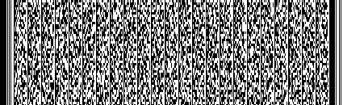 | 191 | 3
CIVID PDF417 Form 2765 V3 | IDCV3♥█Ñ╕1NANCE, PETER B 999007119T DI60165BNBR1973JUN03 2765 2007JAN102010JAN101 0OTHER DOD OTHER TESTING REPLACING LOST CARD | 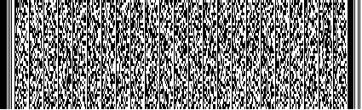 | 193 | 3
DBIDS Code 39 V2 | N201106220 SRSWE |  | 21 | 2
DBIDS Code 39 V3 | 974800010000022159748 |  | 21 | 3
DBIDS PDF417 V2 | IDBD20bêYHOSTNATION, MILITARY 201106220 S60140BNBL1970JUN20 37U2011JUN222014JUN21RSWE |  | 98 | 2
NTS | 5484002N | 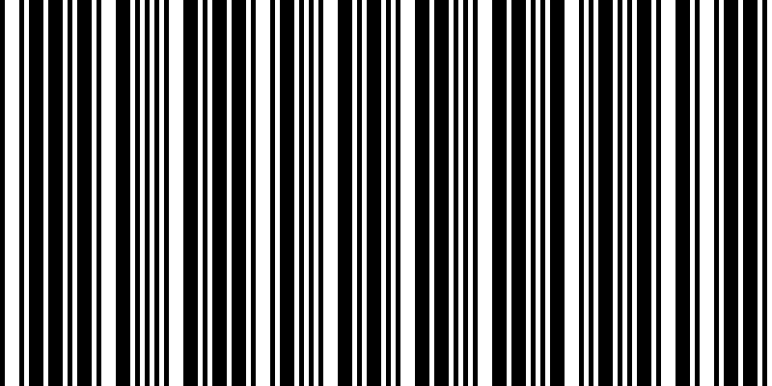 | 8

Not in production
Description | Barcode String | Barcode | Len | Ver
CAC PDF417 V1 | 1AEJMHRS19OJ66MMike Smith B2B6AA00CPL ME04B7VOB9141 |  | 88 | 1
CAC Code 39 | 1Q3E5BGT1RKL5E4AA4 |  | 18 | 1
USID Code 39 V4 size 18 | 49A0NOVV9A0NOVURFP |  | 18 | 4
USID Code 39 V1 | 1TPLIFVMO05 B5J175OR |  | 24 | 1
USID Code 39 V2 | 2TPLIFVME05 J5ROTUBR |  | 24 | 2
USID Code 39 V3 | 3TPLIFVMO04 26MGPFUV | 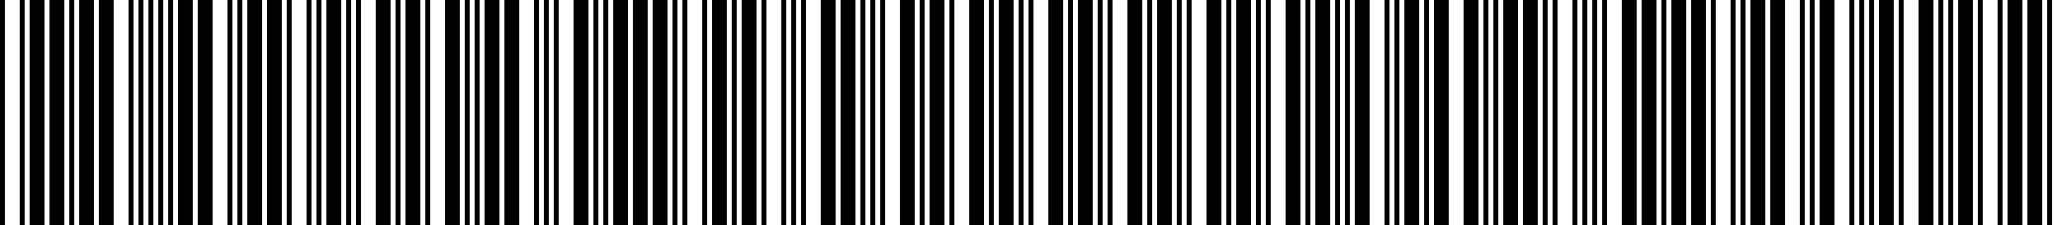 | 24 | 3
USID Code 39 V4 | 4TPLIFVRES T7EPRFV4 | 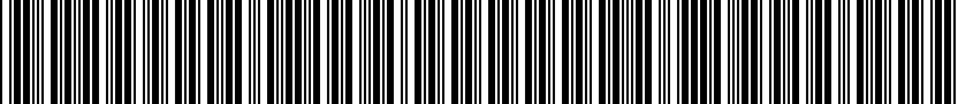 | 24 | 4
USID Code 39 V5 | 5TPLIFVTPLIFV A6KB3OMM |  | 24 | 5
USID Code 39 V6 | 6TPLIFVTPLIFV T6BS9UO3 |  | 24 | 6
USID Code 39 V7 | 701 TPLIFV B6MVNU3C |  | 24 | 7
USID Code 39 V8 | 802 TPLIFV Z6D275GW |  | 24 | 8
USID Code 39 V9 | 9TPLIFVME06 R5QUEZA3 |  | 24 | 9
USID Code 39 VA | ATPLIFVMO03 A64PLDVI | 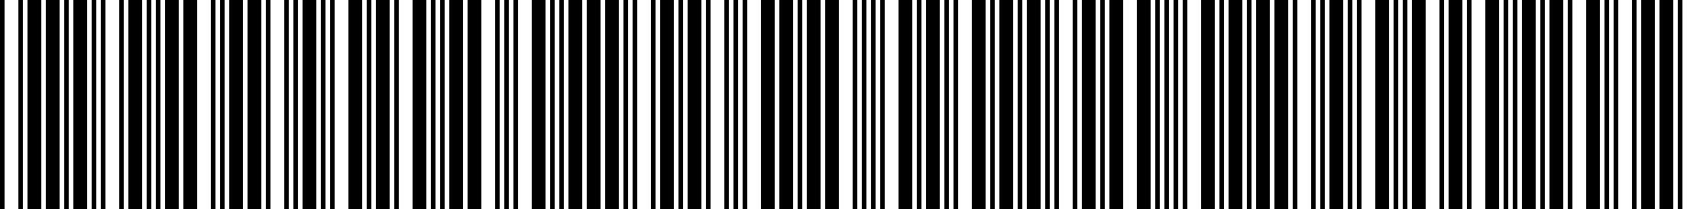 | 21 | A
USID Code 39 VB | BTPLIFVMO05 J5OJJEFA |  | 21 | B
USID Code 39 VC | CTPLIFVMW03 P6N53GR1 |  | 21 | C
USID Code 39 VD | DTPLIFVAD C7708VA0 |  | 21 | D
USID Code 39 VE | ETPLIFVTPLIFVA6QR4MOQ |  | 21 | E
USID Code 39 VF | FTPLIFVTPLIFVR6R5NVJL |  | 21 | F
USID Code 39 VG | G04A TPLIFVD6JAPQW5 |  | 21 | G
USID Code 39 VH | H01A TPLIFVR73CGK12 |  | 21 | H
USID Code 39 VI | ITPLIFVME07 T5SIR5MO |  | 21 | I
USID Code 39 VJ | JTPLIFVAD C7708VA0 |  | 21 | J
USID PDF417 Sponsor V1 | IDUS1*ÇÆ1GORRELL, LIDIA 9991001041 0060150RDBR1992OCT31NNYYUNONE NONE 2RRT2011NOV042052OCT308 5RESRETUSAF AMN I UNK | 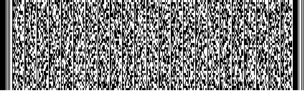 | 149 | 1
USID PDF417 Sponsor V2 | IDUS2*ÇÆ1GORRELL, LIDIA 9991001041 0060150RDBR1992OCT31NNYYUNONE NONE 2RRT2011NOV042052OCT308 5RESRETUSAF AMN E1 I UNK | 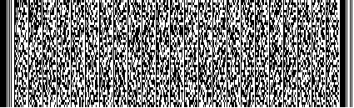 | 153 | 2
USID PDF417 Dependant V1 | IDUS1∩ⁿ╢0TESLIN, WOMAN 99988999819998899980155100GYGY1991NOV17SMYYU2010NOV172013NOV1511732010NOV172013NOV15S BAD USN NON-PO TESLIN, TESLIN 999889999SP | 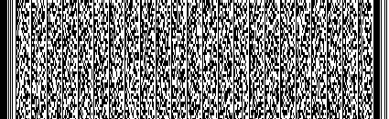 | 185 | 1
USID PDF417 Dependant V2 | IDUS2∩ⁿ╢0TESLIN, WOMAN 99988999819998899980155100GYGY1991NOV17SMYYU2010NOV172013NOV1511732010NOV172013NOV15S BAD USN NON-POE2 TESLIN, TESLIN 999889999SP | 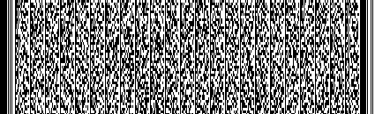 | 189 | 2
CIVID Code 39 VK | KTPLIFV 0DNSQWTE |  | 21 | K
CIVID Code 39 VL | LTPLIFV 0DNSQWTE |  | 21 | L
CIVID Code 39 VM | MTPLIFVE2 0DNSQWTE |  | 21 | M

“Not in production” means cards are no longer issued with barcodes in this format. However, unexpired cards could still be in circulation.

